**Elite Skating Academy Scholarship for boys**

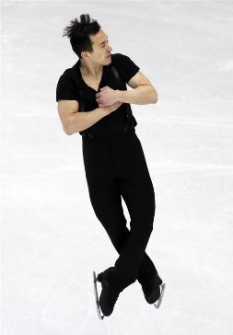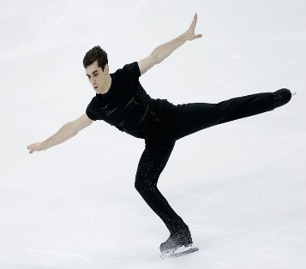

**Objective: The ESA scholarship for boys was established to promote competitive skating for boys in greater Charlotte, NC. The Elite Skating Academy is committed to developing successful competitive skaters from the ground up.**

**Criteria: Applicants must be male, between the ages of 5 and 10 years old. Limited skating experience accepted. Applicant must want to pursue skating, with aspirations to progress through the levels in freestyle or ice dance. Parents of applicants must be committed to promoting their son’s goals in skating.**

**What does the scholarship cover? If a scholarship is awarded, the skater will have free instruction to all scheduled ESA lessons (with prior approval from ESA Director) for two ESA rotations. The skater will only be responsible for their ice time/session fee during this time. Scholarships may be continued after two rotations, if the skater and parents show commitment to the sport. Expectations for each individual applicant will be determined by level and age, and at the discretion of ESA Director- Mathew Gates.**

**Minimum expectations include: Attending one ESA lesson per week fairly consistently (off ice & on ice portions) as well as practicing for 1 hour a week. Skater’s must own their own skates or planning to purchase in the near future.**

**Future commitment: Skaters on scholarship will be expected to have goals (Example: testing or competition) and should pursue private lessons with a professional coach in the near future.**

**How to apply? Application must be completed and submitted to ESA Director, Mathew Gates. Next, a 30 minute evaluation lesson is scheduled. Either Coach Mathew or Andrey will conduct the evaluation. The cost of the evaluation & application process is $20 payable to Elite Skating Academy, LLC. Ice time fee not included. A meeting or phone call will follow to discuss the results of the evaluation lesson. Please find attached application information below.**

**Elite Skating Academy Scholarship for boys**

**Applicant’s Name:**

**Age & Date of Birth:**

**Address:**

**Name & location of School Attended:**

**Other sports/hobbies include:**

**Prior skating experience:**

**Parent’s names:**

**Phone number:**

**Other children?:**

**What are your son’s strengths and weaknesses? Any special talents:** (Example: Strength: Musical. Weakness: Stubborn)

**Additional comments:**

**Parent’s Signature: ____________________ Date: _____________**

**Please submit completed application to ESA Director, Mathew Gates.**

**EliteSkatingAcademyLLC@gmail.com or drop off at front desk- Extreme Ice Center.**

